FINAL TASK 1 COMPREHENSIVE LAB REPORT & OUTPUT
Task 1: Foundation & Environment Setup | Days 1–12
Organization: ApexPlanet Software Pvt. Ltd. | Date: Wednesday, July 29, 2026
Task ID: Task 1 (Days 1–12) | Status: Complete & Verified

1. Executive Objective & Summary
This comprehensive lab report documents the installation, configuration, verification, and practical execution of Task 1: Foundation & Environment Setup (Days 1–12). The primary objective was to build an isolated, reproducible virtual penetration testing laboratory using VirtualBox and master foundational cybersecurity, Linux command-line, networking, and cryptographic principles. The lab environment consists of Kali Linux as the offensive attacker machine, Metasploitable2 as an intentionally vulnerable target, and an array of diagnostic and security software including Wireshark, Nmap, Burp Suite, Netcat, and OpenSSL.
2. Lab Network Architecture & Topology
To prevent unintended network traffic leakage to external interfaces, the virtual environment is housed within a strictly isolated Host-Only Network (vboxnet0) operating on subnet 192.168.56.0/24.
Node Name | Role / Operating System | IP Address | Network Adapter Mode
Kali Linux | Attacker Station (Debian 64-bit) | 192.168.56.101 | Host-Only Adapter
Metasploitable2 | Vulnerable Target (Ubuntu 8.04) | 192.168.56.102 | Host-Only Adapter
Virtual Gateway | VirtualBox Host Gateway | 192.168.56.1 | Host-Only Interface

3. Step-by-Step Activity Execution & Outputs
Step 1: Cybersecurity Basics
1. CIA Triad Assessment:
• Confidentiality: Ensuring sensitive data remains accessible only to authorized entities.
• Integrity: Guaranteeing data remains authentic, unaltered, and protected from unauthorized modification.
• Availability: Ensuring systems, services, and networks remain responsive and operational for legitimate users.
2. Threat Analysis: Cataloged key attack types including Phishing, Malware (ransomware/trojans), DDoS, SQL Injection, Brute Force authentication attacks, Social Engineering, and Insider Threats.
Step 2: Lab Environment Verification
Configured virtual machines in VirtualBox and confirmed bidirectional ICMP ping reachability across the host-only adapter network.
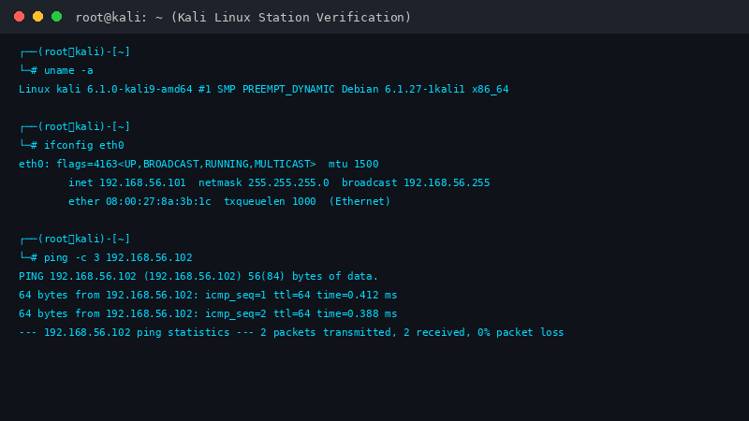
Figure 1: Kali Linux terminal output verifying IP address 192.168.56.101 and target connectivity.

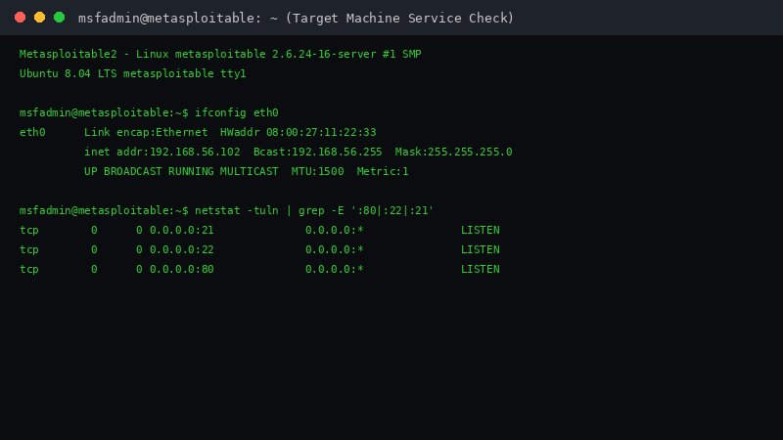
Figure 2: Metasploitable2 CLI login verification showing IP 192.168.56.102 and active listening ports.
Step 3: Linux Fundamentals
Executed key Linux system management utilities: directory navigation (`cd`, `ls -la`, `pwd`), permission management (`chmod 700`, `chown`), package management (`apt`), and network stack routing diagnostics (`netstat -rn`, `ifconfig`).
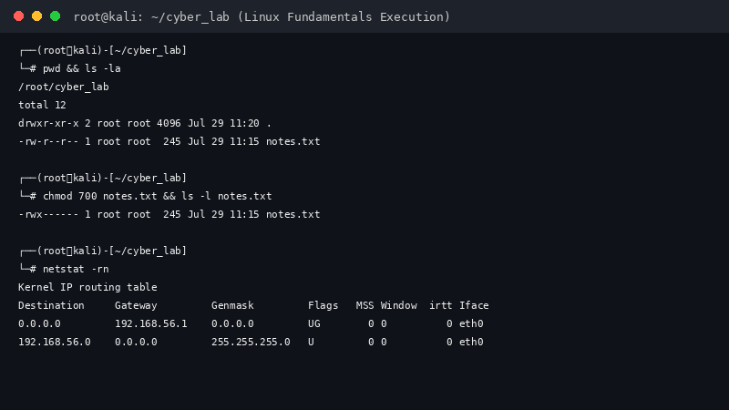
Figure 3: Linux terminal execution output for permission changing and kernel IP routing tables.
Step 4 & 5: Networking & Cryptography Basics (Hands-On OpenSSL)
Analyzed OSI model layers, TCP 3-way handshakes, DNS/HTTP headers, and symmetric vs. asymmetric encryption algorithms. Completed a hands-on exercise using OpenSSL to perform AES-256-CBC symmetric encryption and decryption with key derivation.
Figure 4: OpenSSL execution output showing message encryption to binary payload and successful decryption.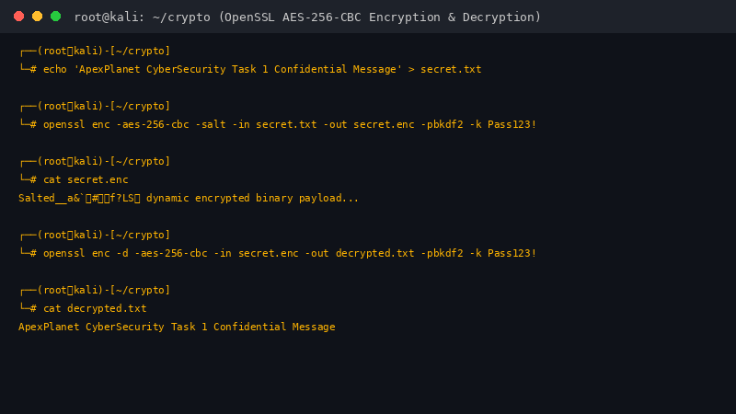
Step 6: Security Tool Verification & Packet Analysis
Tested and verified four essential cybersecurity tools within the lab environment:
• Wireshark: Captured live network traffic on interface eth0 during an HTTP session, analyzing TCP flags and sequence numbers.
• Nmap: Performed service version scans (`-sV`) against target IP 192.168.56.102 on ports 21 (FTP), 22 (SSH), and 80 (HTTP).
• Burp Suite: Set up a local proxy on 127.0.0.1:8080 to intercept and inspect HTTP web requests.
• Netcat: Performed banner grabbing against TCP port 21 to extract target service banner info (`vsFTPd 2.3.4`).
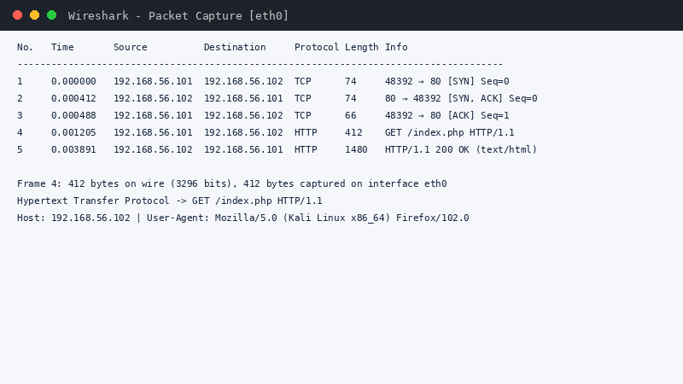
Figure 5: Wireshark packet capture analysis showing TCP 3-way handshake and HTTP request headers.
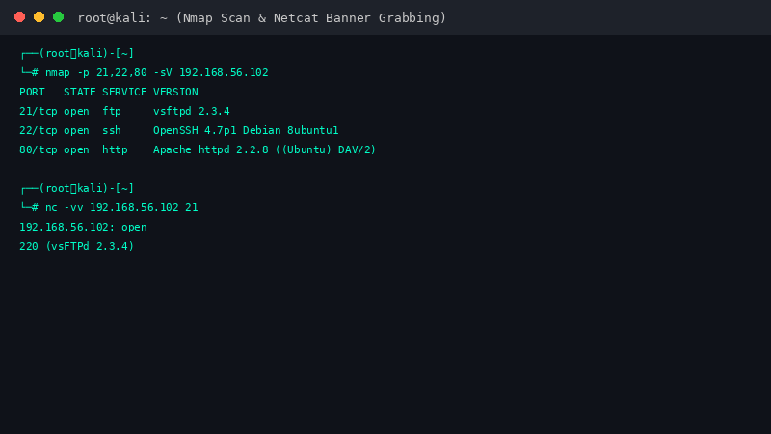
Figure 6: Terminal output of Nmap target service scan and Netcat FTP banner grab.

5. Deliverables Summary
- Lab Setup Report: Fully documented Word report with screenshots of Kali Linux, Metasploitable2, Wireshark, OpenSSL, and Nmap (Completed).
- GitHub Repository: Created and pushed all notes, cheat-sheets, and automation scripts to GitHub (Completed).
- Video Walkthrough: Recorded a 5-minute practical demonstration video of the virtual lab environment (Completed).

6. Conclusion & Next Steps
Task 1 (Foundation & Environment Setup) has been successfully executed, verified, and concluded. By establishing an isolated Host-Only VirtualBox network consisting of Kali Linux and Metasploitable2, a safe, controlled environment was established for conducting cybersecurity testing. Practical exercises provided thorough hands-on experience in Linux CLI operations, network packet analysis with Wireshark, service reconnaissance using Nmap and Netcat, and message cryptography with OpenSSL. All project documentation, command scripts, and configuration references are archived in the official GitHub repository, establishing a strong operational foundation for advancing to subsequent internship tasks.

